The Eight Laws of Health
Consider this! God gave us only eight laws to obey! What a contrast from our world where there are laws without end! Just think of the myriad laws our politicians and law enforcers must interpret and uphold on a daily basis!
But don't be fooled by the simplicity of these eight laws, they contain the secret of true health. When you consider that Jesus desires our health so much that He has given us laws to gain and maintain good health, then the least we can do is to educate ourselves about these laws and at best strive to obey them. For isn't it true that we long to please those whom we love?
It is God’s intention that we be a living sacrifice and honour Him with our bodies, abstaining from harmful things and using in moderation those things that are good. Study these laws carefully, for you will find they will, by God's grace, add happy years of life to you! Think NEW START: Nutrition, Exercise, Water, Sunshine, Temperance, Air, Rest and Trust in God.
Good Nutrition

"Behold I have given you every herb bearing seed, which is upon the face of all the earth, and every tree, in the which is the fruit of a tree yielding seed; to you it shall be for meat." (Genesis 1:29). The word "meat" originates from the Hebrew, oklah, which means food.
Vegetables (the green herb of the field) were not part of the Original Diet given to man, they were added to man's diet after he had sinned and are a part of his diet today.
Therefore, our first duty, one to which we owe to God, to ourselves and to our fellow men is to obey the laws of God, which include the laws of health. The meals should be varied. The same dishes, prepared in the same way, should not appear on the table meal after meal and day after day. The meals are eaten with greater relish, and the system is better nourished, when food is varied.
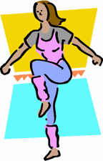
Exercise
Exercise is essential for the body. Morning exercise, in walking in the free, invigorating air of heaven, or cultivating flowers, small fruits, and vegetables, is necessary to a healthful circulation of the blood. It is the surest safeguards against colds, coughs, congestion of the brain and lungs, inflammation of the liver, the kidneys, and the lungs, and a hundred other diseases.
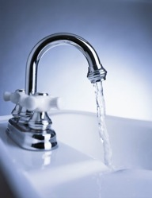
Exercise aids the digestion. When we engage in severe study or violent physical exercise immediately after eating, it hinders the work of digestion; but a short walk after a meal, with the head erect and the shoulders back, is a great benefit.
Water
In health and in sickness, pure water is one of heaven's choicest blessings. Its proper use promotes health. It is the beverage which God provided to quench the thirst of animals and man. Drunk freely, it helps to supply the necessities of the system, and assists nature to resist disease.
Sunlight
Human beings, like plants, need adequate sunlight. If the windows were freed from blinds and heavy curtains, and if the air and sun were permitted to enter the darkened rooms, there would be seen a change for the better in the mental and physical health. The pure air would have an invigorating influence, and the sun that carries healing in its beams would soothe and cheer, and make one happy, joyous and healthy.
Temperance
True temperance teaches us to dispense with everything hurtful and to use judiciously that which is healthful.
Those who understand the laws of health and who are governed by principle, will shun the extremes, both of a self-indulgent appetite or of an insufficient meager diet. Their diet is chosen, not for the mere gratification of appetite, but for the up-building of the body. They seek to preserve every power in the best condition for highest service to God and man. The appetite is under the control of reason and conscience, and they are rewarded with health of body and mind. While they do not urge their views offensively upon others, their example is a testimony in favour of right principles.
Fresh Air
“In order to have good blood, we must breathe well. Full, deep inspirations of pure air, which fill the lungs with oxygen, purify the blood. They impart to it a bright color and send it—a life-giving current—to every part of the body. A good respiration soothes the nerves; it stimulates the appetite and renders digestion more perfect; and it induces sound, refreshing sleep .” The Ministry of Healing, page 272.

“Air is the free blessing of Heaven, calculated to electrify the whole system. Without it the system will be filled with disease, and become dormant, languid, feeble.” Testimonies for the Church, vol. 1, page 701.
Proper Rest
“Come ye apart... and rest” are the words of Jesus. Are you weary and worn with the routine of everyday life? Rest is what you need: physical rest, mental rest, spiritual rest. Come rest awhile. It is one of God’s special healing remedies; and it is just for you, just now.
When every other voice is hushed, and in quietness we wait before Him, the silence of the soul makes more distinct the voice of God. He bids us, ‘Be still and know that I am God.’ Amidst the hurrying throng, and the strain of life’s intense activities, he who is thus refreshed, will be surrounded with an atmosphere of light and peace.” The Ministry of Healing, page 58.
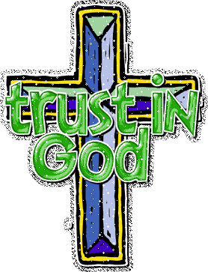
Trust in Divine Power
“Abiding peace, true rest of spirit, has but one Source. It was of this that Christ spoke when He said, ‘Come unto Me, all ye that labor and are heavy laden, and I will give you rest.’ (Matthew 11:28). ‘Peace I leave with you, My peace I give unto you: not as the world giveth, give I unto you.’ (John 14:27). This peace is not something that He gives apart from Himself. It is in Christ, and we can receive it only by receiving Him… When the sunlight of God’s love illuminates the darkened chambers of the soul, restless weariness and dissatisfaction will cease, and satisfying joys will give vigor to the mind, and health and energy to the body.” The Ministry of Healing, page 247.
Can there be more?
The messenger of the Lord has stated that we will have much to learn and much to unlearn. So do you think that there really are only eight laws to health? Maybe you can find more if you search! Let’s see what we can come up with. I know that God is perfect in every way and would leave nothing out that is for our benefit, so let’s dig!

