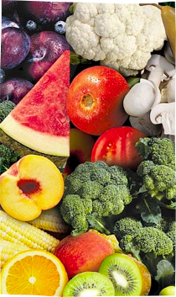
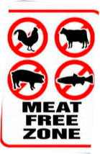
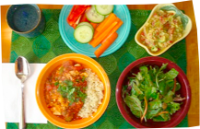
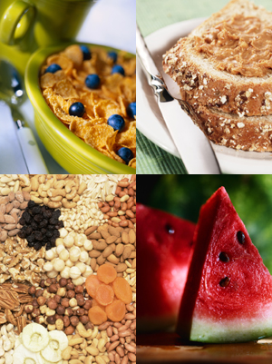
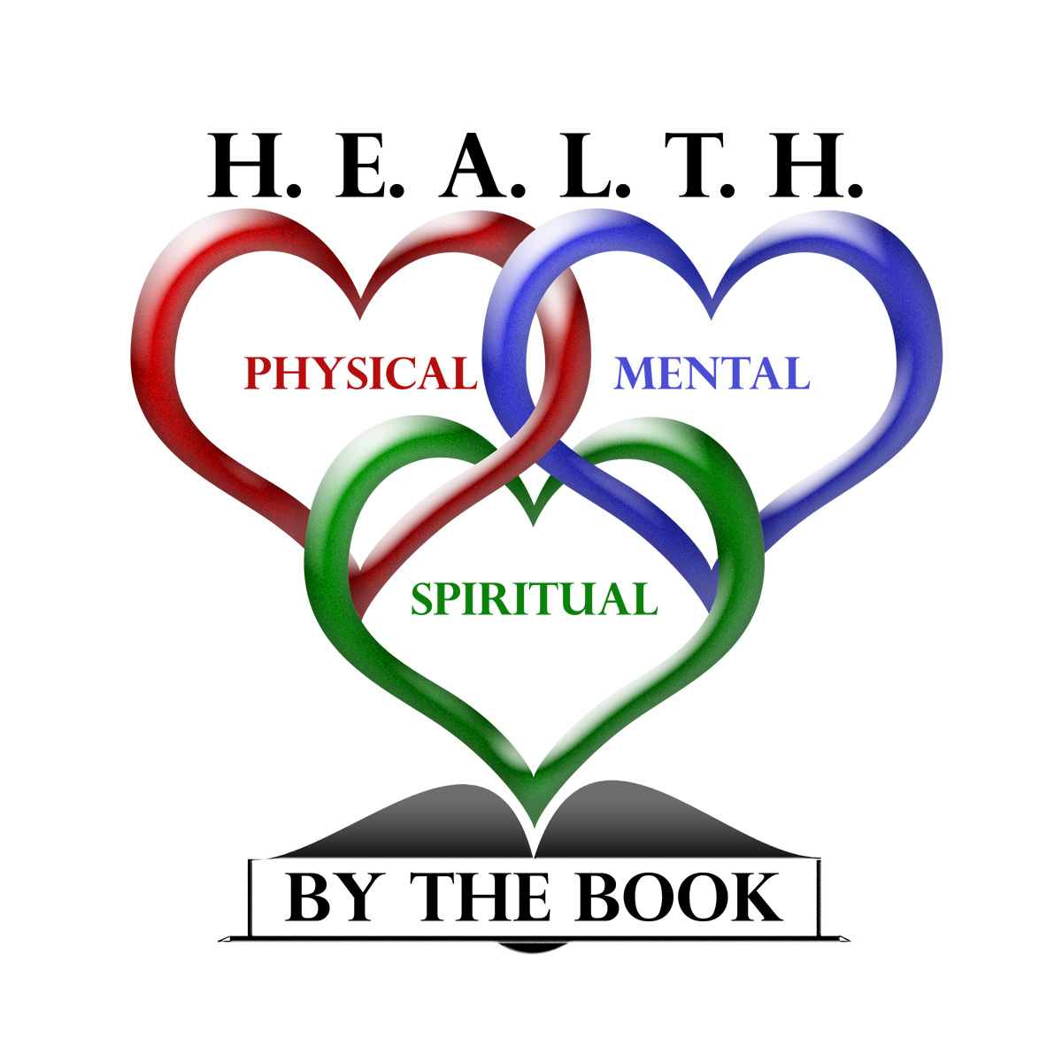
Learn how what you eat impacts your health and how you can make lifestyle changes that will result in a healthier you!
Healthy food that is easy to make and even easier to eat!

Cooking by the Book

H.E.A.L.T.H. by the Book presents

Featuring Delicious, Plant-based recipes

Learn how to cook and eat your way to better health!

Lunch will be provided, so come early and stay all day. For more information contact Your name here or call Your #. Don’t miss out on this opportunity to take charge of your health!

Held at Your Location Here

Your Time Here

